**DEVELOP AND DESIGN A MOBILE OR A WEB APPLICATION TO CHANGE BACKGROUND COLOUR AND MENUE**

**Aim**: To develop and design a mobile or web application to change the background and menu.

**Software Used:** [**https://www.figma.com**](https://www.figma.com)

**Procedure:**

**1.**Insert a frame and create a design for the application.

**2.**Copy the created design and paste the copy of design.

**3.**A new frame will be created.

**4.**Change the background of the copy to another colour.

**5.**Now select prototype on the right side of the screen.

**6.**Now select the desired button which will be used to change the background.

**7.**Press the plus key which will pop and click drag it and connect with the frame 2 and do this process for the frame 2 to frame 1.

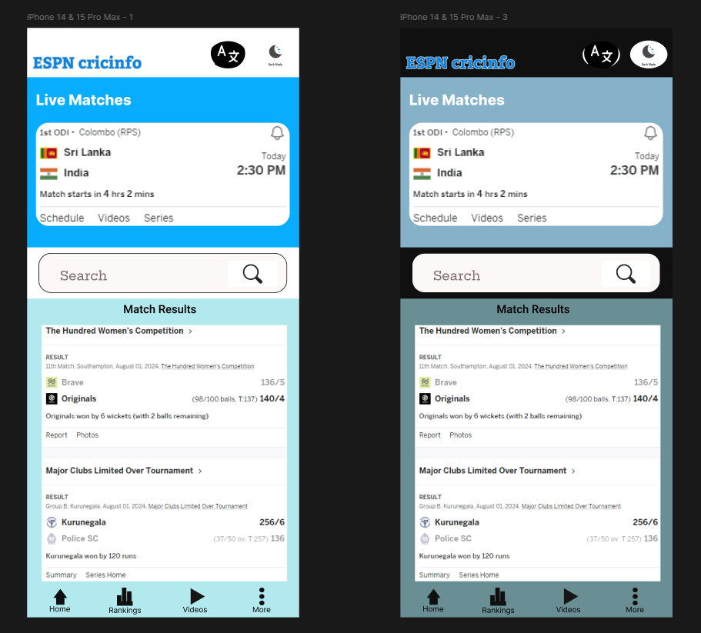

**Result**: We have successfully developed and design a mobile application to change the background colour and menu.